BUSINESS SALES PERFORMANCE ANALYTICS

Power BI Dashboard Report
Prepared By:
- Revanth Reddy Munnangi
Data Science & Analytics Internship Future Interns

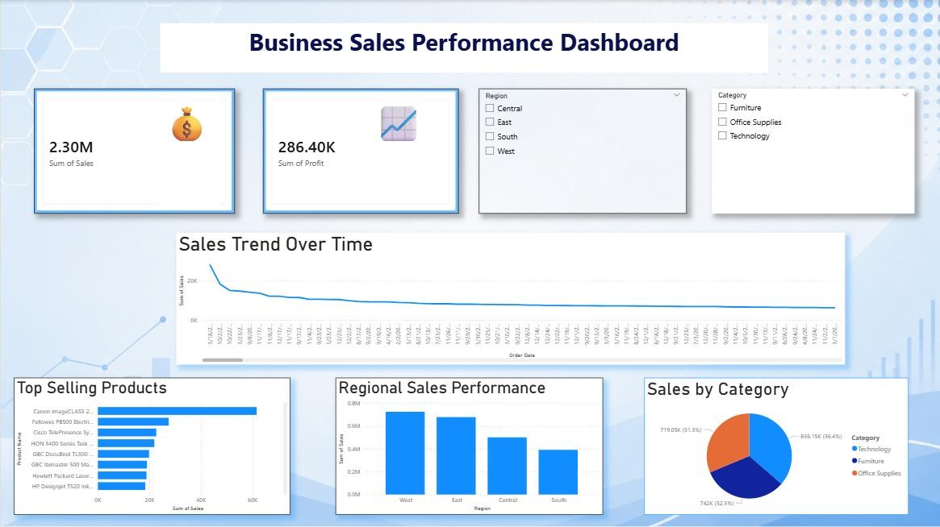

Executive Summary
This report presents a business sales performance analysis created using Power BI. The project focuses on analyzing sales data to identify revenue trends, category performance, regional sales insights, and top-selling products. Interactive dashboards and visualizations were used to better understand business performance and support data-driven decision-making.
The dashboard includes KPI cards, sales trend analysis, category-wise sales distribution, top product analysis, and regional performance comparison. Filters were also added to make the dashboard interactive and userfriendly.
Key Performance Indicators (KPIs)
- Total Sales: 2.30M
- Total Profit: 286K
- Total Quantity Sold: 38K
The analysis showed that the Technology category generated the highest sales, while the West region demonstrated strong business performance and profitability.

Key Insights
- Technology category contributed the highest revenue among all categories.
- West region showed better profitability compared to other regions.
- Certain products generated significantly higher sales than others.
- Sales trends varied across different time periods. • Interactive filters helped analyze regional and category-wise performance efficiently.
Recommendations
- Focus marketing strategies on high-performing categories and products.
- Improve sales strategies in lower-performing regions. • Use sales trend analysis for better business planning and forecasting.
- Continue using interactive dashboards for performance monitoring and decision-making.

Conclusion
This project improved my understanding of business analytics, dashboard development, data visualization, and insight generation using Power BI.

